Group 01, A2

Badhan Automated System Management

**// Here index**

Scope Definition

**Introduction:**

The perfect execution of a real life system depends on a continuous process consists of many phases. Each and every phases consisting of more subsequent phases play an important role to complete the whole system. So in order to accomplish the task of making the system a successful one, we need to first analysis the existing system, find out its drawbacks, how to reduce them, getting the feedback about the system from its users, define its scopes and other aspects. This report deals with these steps describing the information system database of “Badhan”, a voluntary blood donor’s organization runs in the university basis zones, giving it a dynamic shape called “Badhan Automated System Management”.

**Existing System Analysis:**

Badhan is a voluntary organization of blood donors. There are currently 14 Badhan zones around the country. Badhan BUET zone has 7 units as BUET has 7 halls for the under graduate students. So it is easily guessable that each hall is considered as a unit. Each unit is conducted by a committee consisting of 17 members.There is zonal committee for maintaining these units as well.

System’s Current Operating Mechanism:

The work process of Badhan can be described in following structure:

When there is a blood call especially from the hospital, the person who needs the blood, need to contact with the any Badhan zones like Badhan, BUET zone. He/she needs to come in person with the requisition form recommended by a doctor and the blood script where there will be patient’s name, required blood group, the Doctor’s signature, and etc. proof will be evident to ensure that it is not a fraud case, the blood need is emergency.

* Then the Badhan office uses a manual search in the hall units, they try to find out available donors.
* After the manual search is over, the eligible persons, that is, the person who are willing, fit and have the eligible time for donating blood, they are sent for donation.

**Problems with the Current System:**

The roots of this existing system refer to some problems and these are the problem for which we are intending to implement this automated system. The problems are defined below:

* **Mismanagement**: In this manual process of collecting the bloods some mismanagement occurs. Some of them can be:
* The person in need of blood comes the whole way to BUET, but he couldn’t find any eligible person who can donate blood.
* Since the documents are in hard copy, there is higher chance of loss and damage of the information.
* Total internal process may be very slow.

Besides as this organization is totally managed by students, during class and exam times most of the time it has become difficult to contact for blood call and search for donor availability manually.

* **Time consuming**: Since there is no efficient search system, the Badhan office needs to look into its each unit who can donate the required group of blood. Now this is obviously very time consuming and may be proven fatal for the patient too.
* Less Efficient: The mismanagements and the time consuming factor definitely makes this process very inefficient.
* **Repetition**: Let’s assume, there is call for blood group of A (+ve) and Badhan successfully managed the blood call. But now if again there is a call for A (+ve), as there is no dynamic system, same person who donated blood recently may be contacted again. Which is very annoying for donors, time consuming and inefficient.

**Automation Status:**

When do we apply an automation status and why do we intend to do that? Any automation is done to reduce the human labor and save the database that can be recovered in the occasion of loss. But it is evident from the description of the Badhan current operating management system and the problem it deals with is not automated.

The current automation status is almost in the zero level for the Badhan,as it is stated below:

* The database for the donors list, user’s search, and zonal management is manual.
* In every month, the data need to be updated manually.
* In case of loss of data, it’s almost impossible to retrieve it.
* There is some chance that the user may not get the required group of blood for not having a way of easy search of blood.
* The user has to get the blood through many intermediate steps

**Discovering the Scopes:**

Scope of anything means the range of that thing of which we are talking about. So certainly, the system we are talking about has some problems and there is a vast opportunities that if the problems can be solved and the system can be automated, it will of a great help to everyone. Also having a baseline schedule and management of the project plan with the budget of executing the system is under the definitions of scope of a project or system.

The features and the sides will be mainly focusing on the automation of this project is going to be:

* A Dynamic Website
* Automated Database Management
* Direct Donor Availability Search
* Adding New Donor Information
* Updating Existing Donor Information
* Removing a Donor From Database
* Special Management for Negative Blood Group
* Posting and Updating Blood Related Facts
* Badhan Office Contact information
* Emergency Contact Information
* Automatic Monthly Donor Statistics Generation
* Monthly Unit Report Generation
* A virtual Notice board for holding the upcoming event, the notices and the emergency blood calls.
* The whole search process of would be automated:
* User can search nearest Badhan zone
* User can search for the availability of donor for required blood group in that zone and then they can contact with that zone. This will save time as well as manual efforts
* Badhan members can easily list the matched donor from database and contact them
* In case if no donor is available ,a list of various approved blood donation organization ,blood banks and their available contact numbers would be visible to both user and volunteers

***The part of the project not going to be automated:***

The person must have to come to the Badhan office with the requisition form that is given by a hospital to verify if a patient is really in need of blood.The scanned requisition form with doctor’s signature can’t be sent since there is a huge chance of illegal blood trade.Since illegal blood trade is flourishing due to the involvement of hospital employees the phone or any other video conversation and verification can also not be approved.

So, in a word, we are going to be implementing almost whole part of the Badhan system management such as its Donors database, users database, automating the blood calls, public search and this public search part is going to be a vast one as the people who will be in need of blood can have a search on basis of required blood group and also the nearest available blood zone from this current location. Primarily, it is going to be done into the BUET zone, but gradually its domain will be enlarged and finally it will get a shape of whole dynamic system of Badhan.

**Assessment of Project’s Worthiness:**

When does a project will be worthy? A project’s worthiness depends on how best it comes to the benefit of the users, i.e., the people who are going to be benefited through this project.

This system, “Badhan Automated System Management” is absolutely full mark holder in the scale of worthiness. The reasons behind this claim are as justified below:

* **Eliminating the intermediate steps**: When Badhan will be having a dynamic database system, the intermediate steps such as contacting with the Badhan office, manually searching the units of it, judging the persons who are fit to donate the bloods etc is going to be eliminated.
* Not only the Badhan at BUET zone, but also the other zones, Badhan has 14 zones in different universities, need to be connected virtually. It will give ease of access to communicate with the other members or other zones of the main committee of Badhan.
* All the databases will be now automated so that any loss of database has no chance of occurrence.
* Updating the info of both the blood donors and the zonal members will be now easy and less time consuming.
* All the repetitions and mismanagements can be reduced to almost zero level as everything is going to be updated in the systematic database.

**Possible Roadblocks for the Proposed System:**

Roadblock means the probable problems that may be encountered in the accomplishment of the proposed system. For these problems, necessary survey was done by our team-mates. From the survey, what we faced that the only road-block may be in our system is that the person who has the need for the blood has to come in body. Actually, we could have eliminated this problem by giving us an electronic copy of the prescription of doctor with his seals and other requirements that can prove the person that he is not fraud and really has the need for blood.

But in the country that had become five times champion in corruption, we just can’t get convinced that the blood call is really in need. So, the person needs to verify by bringing the required certificates bearing the signature of the doctor/ seal of the regarding hospital, the patients’ medical form, etc.

In order to encounter this problem, we have arranged the user search that can make the whole process faster. The user can search the required blood through zonal search or group-wise search. But in the case of need of blood, we just can’t help the problem of coming in body to the Badhan office for the sake of transparency of the process to prevent the blood business.

Besides, since this organization is entirely voluntary and is managed by membership fees, donation etc. maintaining a web site as well as an application would be expensive. Sometimes it could be hard to bear this cost.

But this can be solved by increasing membership cost a bit, besides by setting up a money donation system would also be helpful in this case.

**Use Case**

Actors

* User
* Donor
* Unit Member
* Zonal Member
* Central Member
* Moderator ( All Zonal Presidents & Club Moderators)
* Admin (Central Badhan President)
* Advisor
* Hospital Representative
* Time (System)

**Actors Glossary**

|  |  |  |
| --- | --- | --- |
| **Actors** | **Short-Key** | **Activity Scope** |
| **User** | **USR** | **Check Availability & Makes Blood Call** |
| **Donor** | **DNR** | **Donate Blood & Update Info** |
| **Unit Member** | **UM** | **Authenticate ,Search , Confirm Blood Calls** |
| **Zonal Member** | **ZM** | **Monitor Unit Activities** |
| **Central Member** | **CM** | **Monitor Zonal Activities** |
| **Moderator** | **MOD** | **Verify Accounts** |
| **Admin** | **ADM** | **Control Whole System** |
| **Advisor** | **ADV** | **Gives Direction & Occasional Financial Support** |
| **Hospital Representative** | **HR** | **Verify Scanned Requisition Form** |

**Subsystems:**

There are total five subsystems in our project. They are,

* Database Management
* Search Management
* Meeting Management
* Notification Management
* Automated Requisition Form

1. Database Management :

**Subsystem Actors:**

* Donors
* Unit Member(UM)
* Zonal Member(ZM)
* Moderator(MOD)

|  |  |  |
| --- | --- | --- |
| **Use-Case ID > Name** | **Description** | **Participant Actors** |
| 1.1 > Volunteer for Donation | Donor volunteers for blood donation and informs a unit member | Donor fills up form and unit member receives request |
| 1.2 > Add Donor | Unit member adds donor if found eligible for blood donation | Unit member updates donor database |
| 1.3 > Remove Donor | Unit member removes donor from database if donor no longer available for further blood donation | Unit member |
| 1.4 > Donor Update Regarding Donation | Donor informs unit member after a blood donation | Unit member and donor |
| 1.5 > Donor Database Update | Unit member updates donor database | Unit member |
| 1.6 > User Database Management | Zonal members conducts modifications to user database | Zonal committee member |
| 1.7 > Member Database Management | Club moderator maintains member database | Moderator |

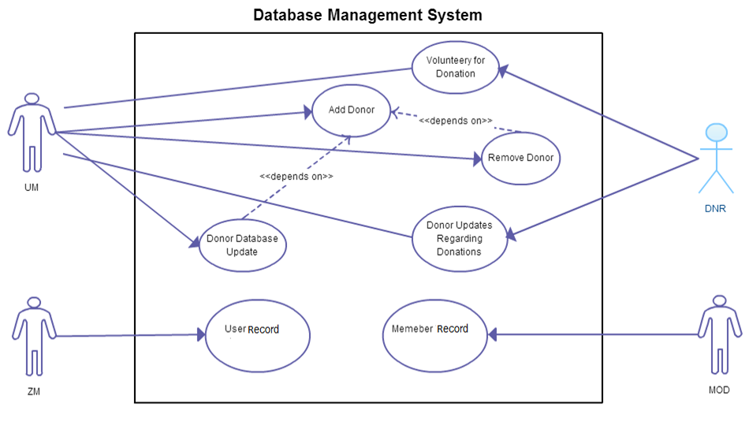

**Fig: Use-Case Diagram for Database Management System**

* 1. **VOLUNTEERY FOR DONATION**

|  |  |
| --- | --- |
| **Use-Case Name** | **Volunteer for Donation** |
| Use-Case ID | 1.1 |
| Priority | High |
| Primary Business Actor | Donor(DNR) |
| External Receiver Actor | Unit Member(UM) |
| Description | Donor volunteers for blood donation and informs a unit member |
| Trigger | By DNR |

**Typical Course of Events:**

|  |  |
| --- | --- |
| **Actor Action** | **System Response** |
| 1. Donor volunteers for donation | 2. Request to be forwarded to a unit member |
| 3. Unit member receives a donor request |  |

**Documentation of Use-Case 1.1:**

* Conclusion : Concludes when a unit member receives the request for blood donation volunteer
* Post Condition : Unit member checks donor’s eligibility for blood donation
* Implementation Issue: Interested donors can fill up forms online and submit request for becoming a donor. This process can also be done manually, in person
  1. **ADD DONOR:**

|  |  |
| --- | --- |
| **Use-Case Name** | **Add Donor** |
| Use-Case ID | 1.2 |
| Priority | High |
| Primary System Actor | Unit Member(UM) |
| Description | Unit member adds new donor information in database |
| Trigger | By UM |
| Typical Course of Event | Unit member adds new donor to database |

**Documentation of Use-Case 1.2:**

* **Conclusion : Concludes when a unit member makes entry in database regarding information of new donor**
* **Post Condition : Donor information is added to database**
* **Implementation Issue: System contains the donor database. Unit member makes entry to this database from their account** 
  1. **REMOVE DONOR :**

|  |  |
| --- | --- |
| **Use-Case Name** | **Remove Donor** |
| Use-Case ID | 1.3 |
| Priority | High |
| Primary System Actor | Unit Member(UM) |
| Description | Unit member removes donor information if donor no longer can donate blood(Example scenario: donor left the education institute) |
| Trigger | By UM |
| Typical Course of Event | Unit member removes donor from database |

**Documentation of Use-Case 1.3:**

* Conclusion : Concludes after the unit member makes a deletion of a donor entry from donor database
* Pre Condition : Target donor has been added to database before
* Post Condition : A donor record is erased from donor database
* Implementation Issue: System contains donor database. Unit members can erase a donor from their account
  1. **DONOR UPDATES REGARDING DONATIONS :**

|  |  |
| --- | --- |
| **Use-Case Name** | **Donor Updates Regarding Donation** |
| Use-Case ID | 1.4 |
| Priority | Medium |
| Primary Business Actor | Donor(DNR) |
| External Receiver Actor | Unit Member(UM) |
| Description | Donor informs unit member after a blood donation or other info (Example – contact/room no change etc) |
| Trigger | By DNR |
| Typical Course of Event | Donor informs a unit member of recent blood donation or concerning updates possibly by filling up a form online or informing unit member in person |

**Documentation of Use-Case 1.4:**

* Conclusion : Concludes when a unit member receives update of recent blood donation from a donor
* Post Condition : Unit member updates donor database
  1. **DONOR DATABASE UPDATE :**

|  |  |
| --- | --- |
| **Use-Case Name** | **Donor Database Update** |
| Use-Case ID | 1.5 |
| Priority | High |
| Primary Business Actor | Unit Member(UM) |
| Description | Unit member updates donor records regarding latest donation or other donor details |
| Trigger | By UM |
| Typical Course of Event | Unit member updates donor records regarding latest donation or other donor details |

**Documentation of Use-Case 1.4:**

* Conclusion : Concludes after unit member updates donor information in database
* Pre Condition : Target donor has been added to database before
* Post Condition : Donor database up-to-date
* Implementation Issue : Donor database can be accessed by unit members and they can update existing records
  1. **USER DATABSE MANAGEMENT :**

|  |  |
| --- | --- |
| **Use-Case Name** | **User Database Management** |
| Use-Case ID | 1.6 |
| Priority | Medium |
| Primary Business Actor | Zonal Committee Member(ZM) |
| Description | * During blood calls, zonal members check user database for user’s previous records. * New user added. * Update information on existing user. |
| Trigger | By ZM |

**Typical Course of Events:**

|  |  |
| --- | --- |
| **Actor Action** | **System Response** |
| 1. User makes a blood call |  |
| 2. Zonal member receives blood call |  |
| 3. Zonal member authenticates user and searches user database | 4. No user entry in the system |
| 5. Zonal member adds new user to database | 6. New user added |

**Alternate Course of Events:**

|  |  |
| --- | --- |
| **Actor Action** | **System Response** |
| 1. User makes a blood call |  |
| 2. Zonal member receives blood call |  |
| 3. Zonal member authenticates user and searches user database | 4. System returns user information |
| 5. User information from database helps zonal member for authentication |  |
| 6. Zonal member updates user information on database regarding current blood call | 7. User database up-to-date |

**Documentation of Use-Case 1.6:**

* Conclusion : Concludes when a zonal committee member makes an entry or modifies an entry in user database
* Post Condition : User database is up-to-date containing blood call records for users
* Implementation Issue: User database is contained in the system. Zonal committee members can log-in to their account to update user database
  1. **MEMBER DATABASE MANAGEMENT :**

|  |  |
| --- | --- |
| **Use-Case Name** | **User Database Management** |
| Use-Case ID | 1.7 |
| Priority | High |
| Primary Business Actor | Moderator(MOD) |
| Description | Moderator adds or removes members and updates member information(Example : member promotion) |
| Trigger | By MOD |
| Typical Course of Events | * Adds new member * Removes existing member * Updates record of existing member |

**Documentation of Use-Case 1.7:**

* Conclusion : Concludes when a club moderator makes an entry or modification or removal of a member record
* Post Condition : Member database is up-to-date
* Implementation Issue: Club moderator has access to member’s database. He can alter records in the database

1. **Search Management System:**

|  |  |  |
| --- | --- | --- |
| **Use-Case ID > Name** | **Description** | **Participant Actors** |
| 2.1 > Donor Availability Check | Returns Specific Donor Availability in the Nearest Badhan Zone | USR, CM |
| 2.2 > Unit Donor Availability List | Returns Available Donor List of the Respective Unit | UM |
| 2.3 > Zonal Donor Availability List | Returns Available Donor List of the Respective Zone | ZM |
| 2.4 > Member Search | Search & Returns All Current or Previous Badhan Members Information & Unit / zonal / Central Committee List | UM,ZM,CM,ADV |

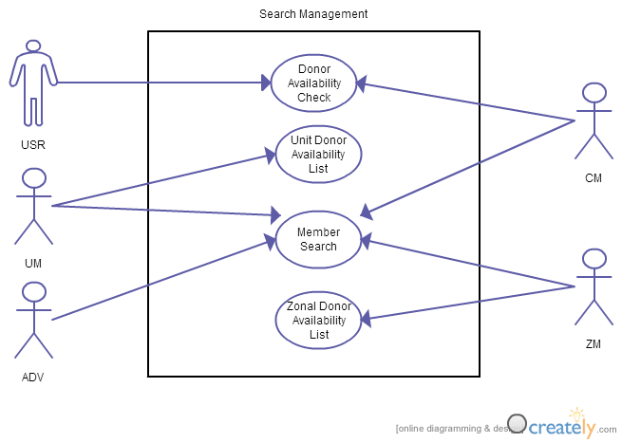

**Fig: Use-Case Diagram for Search Management System**

* 1. **DONOR AVAILABILITY CHECK :**

|  |  |
| --- | --- |
| **Use-Case Name** | **Donor Availability Check** |
| Use-Case ID | 2.1 |
| Priority | High |
| Primary Business Actor | User (USR) |
| External Receiver Actor | User (USR) |
| Description | Returns Specific Donor Availability in the Nearest Badhan Zone |
| Trigger | By USR |

**Typical Course of Event:**

|  |  |
| --- | --- |
| **Actor Action** | **System Response** |
| 1. User Selects the Nearest Zone of Badhan |  |
| 2. User then search if required blood donor is available in that zone | 3. System responded with yes /no |
| 4. If no then user checks the other Badhan zone and if any donor available there | 5. System retrieve these information from database and inform the USR |
| 6. User checks the contact information of the required zone | 7. System respond with contact informations & other process to make blood call |

**Documentation of Use-Case 2.1:**

* Conclusion: User will get to know where and how to find blood donor promptly
* Post-Condition: User come the Badhan office to verify and inform them about his required blood
  1. **UNIT DONOR AVAILABILITY CHECK:**

|  |  |
| --- | --- |
| **Use-Case Name** | **Unit Donor Availability List** |
| Use-Case ID | 2.2 |
| Priority | High |
| Primary Business Actor | Unit Member(UM) |
| Description | System informs about the available donor, their current blood donation statistics and contact information of the required blood group in the respective units |
| Trigger | By UM |

**Typical Course of Events:**

|  |  |
| --- | --- |
| **Actor Action** | **System Response** |
| 1. Unit member queries about the required blood group | 2. System extracts information about the donor of the respective blood group from database and provide with their necessary information |
| 3. Unit member checks donor’s current blood donation statistics and queries if blood donation possible |  |
| 4. Unit member contact with donor & confirms |  |

**Documentation of Use-Case 2.2:**

* Conclusion: Unit member will find the available donor as well as their contact information and blood donation statistics
* Post-Condition: Unit member then tries to contact with the available donor and finds out who are willing to donate blood that time
* Implementation Issues: The extraction of available donor is maintained by system database
  1. **ZONAL DONOR AVAILABILITY LIST:**

|  |  |
| --- | --- |
| **Use-Case Name** | **Zonal Donor Availability List** |
| Use-Case ID | 2.3 |
| Priority | High |
| Primary Business Actor | Zonal Member(ZM) |
| Description | System informs about the available donor, their current blood donation statistics and contact information of the required blood group donors of all units of the respective zone |
| Trigger | By ZM |

**Typical Course of Events:**

|  |  |
| --- | --- |
| **Actor Action** | **System Response** |
| 1. ZM queries about the required blood group | 2. System extracts information about the donor of the respective blood group from database and provide with their necessary information |
| 3. ZM checks donor’s current blood donation statistics and queries if blood donation possible |  |
| 4. ZM contact with donor & confirms |  |

**Documentation of Use-Case 2.3:**

* Conclusion: ZM will find the available donor as well as their contact information and blood donation statistics
* Post-Condition: ZM then tries to contact with the available donor and finds out who are willing to donate blood that time
* Implementation Issues: the entire extraction of available donor out of the huge list and preparing list is maintained by system database
  1. **MEMBER SEARCH :**

|  |  |
| --- | --- |
| **Use-Case Name** | **Member Search** |
| Use-Case ID | 2.4 |
| Priority | Normal |
| Primary Business Actor | UM,ZM,CM,ADV |
| Description | Search & Returns All Current or Previous Badhan Members Information & Unit / zonal / Central Committee List |
| Trigger | By UM,ZM,CM,ADV |

**Typical Course of Events:**

|  |  |
| --- | --- |
| Actor Action | System Response |
| 1. UM,CM,ZM,ADV search/query about any Badhan member or Unit/Zonal/Central Committee List | 2. System provides the member information or Committee list |

**Documentation of Use-Case 2.4:**

* Conclusion: All the Badhan members can be up to date with other members current status, contact informations
* Post-Condition: CM,ZM,UM,ADV can find out any query relating to current , past Badhan members
* Implementation Issues: the list of member information is managed by system database

1. **Meeting Management:**

|  |  |  |
| --- | --- | --- |
| **Use-Case ID > Name** | **Description** | **Participant Actors** |
| 3.1 > Zonal Event Creation | UM, ZM create new event | UM,ZM |
| 3.2 > Zonal New Post | UM, ZM ,ADV create new discussion | UM,ZM,ADV |
| 3.3 > Zonal Post Moderation | UM, ZM modify a post if necessary | UM,ZM |
| 3.4 > Zonal Post Remove | Only MOD remove a post if necessary | MOD |
| 3.5 > Central Event Creation | CM create new central event | CM |
| 3.6 > Central New Post | CM,ZM,ADV create new discussion | CM,ZM,ADV |
| 3.7 > Central Post Moderation | CM modify a post if necessary | CM |
| 3.8 > Central Post Remove | Only ADM remove a post if necessary | ADM |

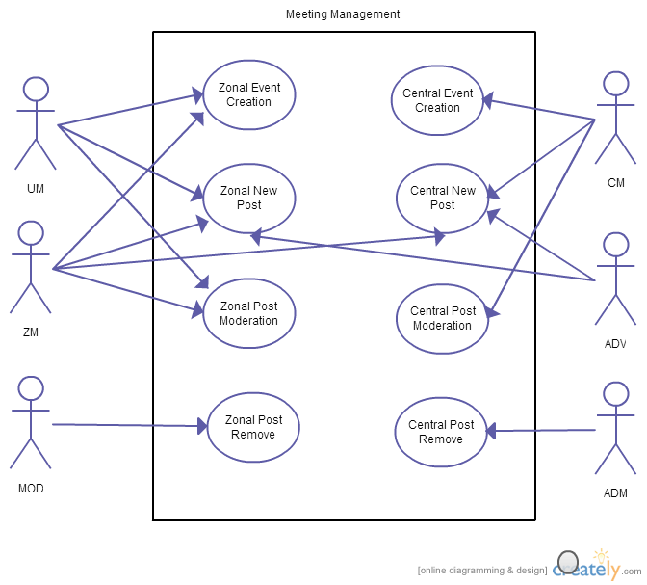

**Fig: Use-Case Diagram for Meeting Management System**

* 1. **ZONAL EVENT CREATION:**

|  |  |
| --- | --- |
| **Use-Case Name** | **Zonal Event Creation** |
| Use-Case ID | 3.1 |
| Priority | High |
| Primary Business Actor | UM,ZM |
| Description | UM,ZM create new event |
| Trigger | UM,ZM |

**Typical Course of Events:**

|  |  |
| --- | --- |
| **Actor Action** | **System Response** |
| 1. UM,ZM create event | 2. Notification Sent to respective UM,ZM,ADV |
| 3. UM,ZM,ADV response accordingly |  |

**Documentation of Use-Case 3.1:**

* Conclusion : Concludes when the event date is expired
* Post Condition : According to External Receiver Actor’s feedback

**3.2 ZONAL NEW POST:**

|  |  |
| --- | --- |
| **Use-Case Name** | **Zonal New Post** |
| Use-Case ID | 3.2 |
| Priority | High |
| Primary Business Actor | UM, ZM, ADV |
| Description | UM,ZM,ADV create new discussion |
| Trigger | By UM, ZM, ADV |

**Typical Course of Events:**

|  |  |
| --- | --- |
| **Actor Action** | **System Response** |
| 1. UM, ZM, ADV create new discussion | 2. Notification Sent to respective UM, ZM, ADV |
| 3. UM, ZM, ADV response accordingly |  |

**Documentation of Use-Case 3.2:**

* Conclusion : When MODs remove the post
* Post Condition : According to External Receiver Actor’s feedback

**3.3 ZONAL POST MODERATION:**

|  |  |
| --- | --- |
| **Use-Case Name** | **Zonal Post Moderation** |
| Use-Case ID | 3.3 |
| Priority | High |
| Primary Business Actor | UM,ZM |
| Description | UM,ZM modify a post if necessary |
| Trigger | By UM,ZM |
| Typical Course of Event | UM,ZM modify a post if necessary |

**Documentation of Use-Case 3.2:**

* Conclusion : Concludes when a MOD remove the post
* Post Condition : According to MOD’s action

**3.4 ZONAL POST REMOVE:**

|  |  |
| --- | --- |
| **Use-Case Name** | **Zonal Post Remove** |
| Use-Case ID | 3.4 |
| Priority | Normal |
| Primary Business Actor | MOD |
| Description | Only MOD remove a post if necessary |
| Trigger | By MOD |
| Typical Course of Event | MOD remove a post if necessary |

**Documentation of Use-Case 3.3:**

* Conclusion : Concludes immediately

**3.5 CENTRAL EVENT CREATION:**

|  |  |
| --- | --- |
| **Use-Case Name** | **Central Event Creation** |
| Use-Case ID | 3.5 |
| Priority | Normal |
| Primary Business Actor | CM |
| External Receiver Actor | CM,ZM,ADV |
| Description | CM create new central event |
| Trigger | By CM |

**Typical Course of Events:**

|  |  |
| --- | --- |
| **Actor Action** | **System Response** |
| 1. CM create event | 2. Notification Sent to CM,ZM & ADV |
| 3. CM, ZM & ADV response accordingly |  |

**Documentation of Use-Case 3.4:**

* Conclusion : Concludes when the event date is expired
* Post Condition : According to External Receiver Actor’s feedback

**3.6 CENTRAL NEW POST:**

|  |  |
| --- | --- |
| **Use-Case Name** | **Zonal New Post** |
| Use-Case ID | 3.6 |
| Priority | Normal |
| Primary Business Actor | CM, ZM, ADV |
| Description | CM, ZM, ADV create new discussion |
| Trigger | By CM, ZM, ADV |

**Typical Course of Events:**

|  |  |
| --- | --- |
| **Actor Action** | **System Response** |
| 1. CM, ZM, ADV create new discussion | 2. Notification Sent to respective CM, ZM, ADV |
| 3. CM, ZM, ADV response accordingly |  |

**Documentation of Use-Case 3.5:**

* Conclusion : When ADM remove the post
* Post Condition : According to External Receiver Actor’s feedback

**3.7 CENTRAL POST MODERATION:**

|  |  |
| --- | --- |
| **Use-Case Name** | **Zonal Post Moderation** |
| Use-Case ID | 3.3 |
| Priority | Normal |
| Primary Business Actor | CM |
| Description | CM modify a post if necessary |
| Trigger | By CM |
| Typical Course of Event | CM modify a post if necessary |

**Documentation of Use-Case 3.7:**

* Conclusion : Concludes when ADM remove the post
* Post Condition : According to ADM action

**3.8 CENTRAL POST REMOVE:**

|  |  |
| --- | --- |
| **Use-Case Name** | **Central Post Remove** |
| Use-Case ID | 3.8 |
| Priority | Normal |
| Primary Business Actor | ADM |
| Description | Only ADM remove a post if necessary |
| Trigger | By ADM |
| Typical Course of Event | ADM remove a post if necessary |

**Documentation of Use-Case 3.8:**

* Conclusion : Concludes immediately

1. **NOTIFICATION MANAGEMENT**

|  |  |  |
| --- | --- | --- |
| **Use-Case ID > Name** | **Description** | **Participant Actors** |
| 4.1 > Donor Notification | Emergency blood call’s notification sent to available donor | DNR,UM |
| 4.2 > Zonal Meeting Notification | Zonal Meeting Notification sent to UM,ZM,ADV | Time,UM,ZM,ADV |
| 4.3 > Central Meeting Notificatin | Central Meeting Notification sent to CM,ZM,ADV | Time,CM,ZM,ADV |

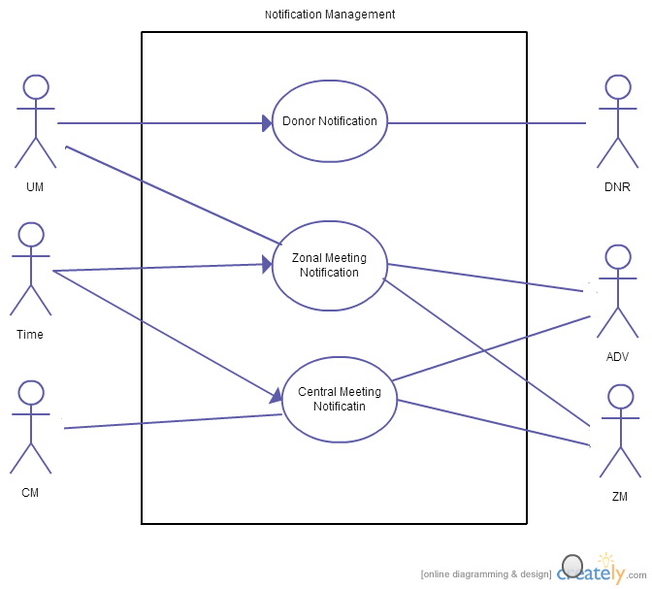

**Fig: Use-Case Diagram for Notification Management System**

* 1. **DONOR NOTIFICATION:**

|  |  |
| --- | --- |
| **Use-Case Name** | **Zonal Event Creation** |
| Use-Case ID | 4.1 |
| Priority | High |
| Primary Business Actor | UM |
| External Receiver Actor | DNR |
| Description | Emergency blood call’s notification sent to available DNR |
| Trigger | By UM |

**Typical Course Of events:**

|  |  |
| --- | --- |
| **Actor Action** | **System Response** |
| 1. Notification sent to donor |  |
| 2.UM receives DNR reply |  |

**Documentation of Use-Case 4.1:**

* Conclusion : Concludes when DONR replies
* Post Condition : According to DONR’s feedback
  1. **ZONAL MEETING NOTIFICATION:**

|  |  |
| --- | --- |
| **Use-Case Name** | **Zonal Meeting Notification** |
| Use-Case ID | 4.2 |
| Priority | High |
| Primary Business Actor | Time |
| External Receiver Actor | UM,ZM,ADV |
| Description | Zonal Meeting Notification sent to UM,ZM,ADV |
| Trigger | By Time |
| Typical Course of Event | System sends notification to UM,ZM,ADV |

**Documentation of Use-Case 4.2:**

* Conclusion : Concludes when notification is sent
  1. **CENTRAL NOTIFICATION:**

|  |  |
| --- | --- |
| **Use-Case Name** | **Zonal New Post** |
| Use-Case ID | 4.3 |
| Priority | Normal |
| Primary Business Actor | Time |
| External Receiver Actor | CM, ZM, ADV |
| Description | Central Meeting Notification sent to CM,ZM,ADV |
| Trigger | By System |
| Typical Course of Event | System sends notification to CM,ZM,ADV |

**Documentation of Use-Case 4.3:**

* Conclusion: Concludes when notification is sent.

1. **Automated Requisition Form**

|  |  |  |
| --- | --- | --- |
| **Use-Case ID > Name** | **Description** | **Participant Actors** |
| 5.1 > Scan & Upload Requisition form | The requisition form is scanned and uploaded by user to send to UM. | USER (USR) |
| 5.2 > Verification of Requisition Form | The uploaded requisition form is verified by both HR and UM. | HOSPITAL REPRESENTATIVE (HR), UNIT MEMBER(UM) |

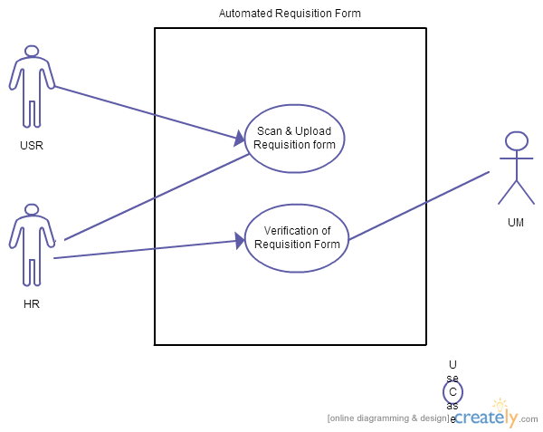

**Fig: Use-Case Diagram for Automated Requisition Form**

* 1. **SCAN AND UPLOAD REQUISITION FORM:**

|  |  |
| --- | --- |
| **Use-Case Name** | **Scan & Upload Requisition Form** |
| Use-Case ID | 5.1 |
| Priority | High |
| Primary Business Actor | USER(USR) |
| External Receiver Actor | HR |
| Description | The requisition form is scanned and uploaded by user to send to HR. |
| Trigger | By USR |

**Typical Course of Events:**

|  |  |
| --- | --- |
| **Actor Action** | **System Response** |
| 1. USER uploads the requisition form after scanning it. |  |
| 2. UM & HR gets the scanned form to check over it. |  |

**Documentation of Use-Case 5.1:**

* Conclusion : Concludes when the scanned requisition form is uploaded
  1. **VERIFICATION OF REQUISITION FORM:**

|  |  |
| --- | --- |
| **Use-Case Name** | **Verification of Requisition Form** |
| Use-Case ID | 6.2 |
| Priority | High |
| Primary Business Actor | HR |
| External Receiver Actor | UM |
| Description | The uploaded requisition form is verified by both HR and sent to UM. |
| Trigger | By HR |

**Typical Course of Events:**

|  |  |
| --- | --- |
| **Actor Action** | **System Response** |
| 1. HR verifies the requisition form. | 2. Sends Verification form to UM. |
| 3.UM receives the scanned requisition form |  |

**Documentation of Use-Case 5.2**

* Conclusion : Concludes when requisition form verified by the UM is completed

**SYSTEM ARCHITECTURE**

**Class and Collaboration Diagrams:**

Now the corresponding class and collaboration diagram for the use-cases of respective sub-systems that have been described above is given below:

1. **Database Management**
   1. **Volunteer for Donation**

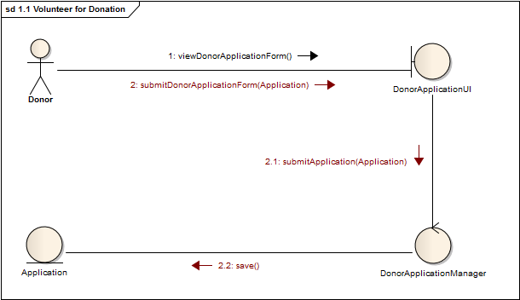

Fig 1.1.1: Collaboration Diagram

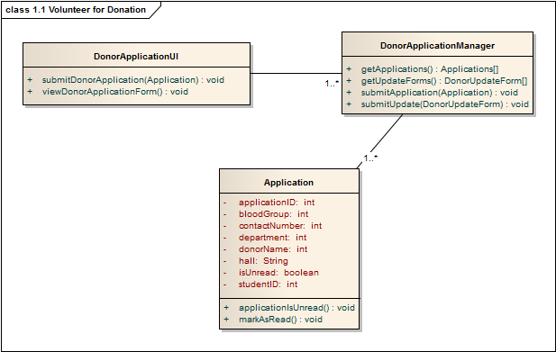

Fig 1.1.2: Class Diagram

* 1. **Add Donor**

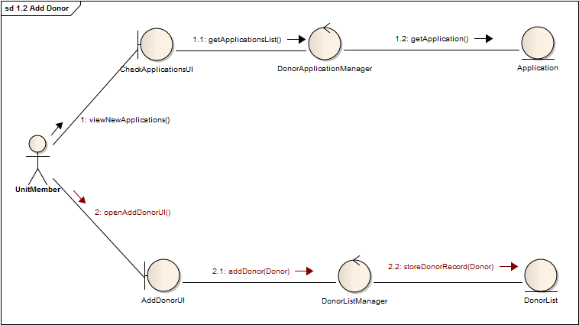

Fig 1.2.1: Collaboration Diagram

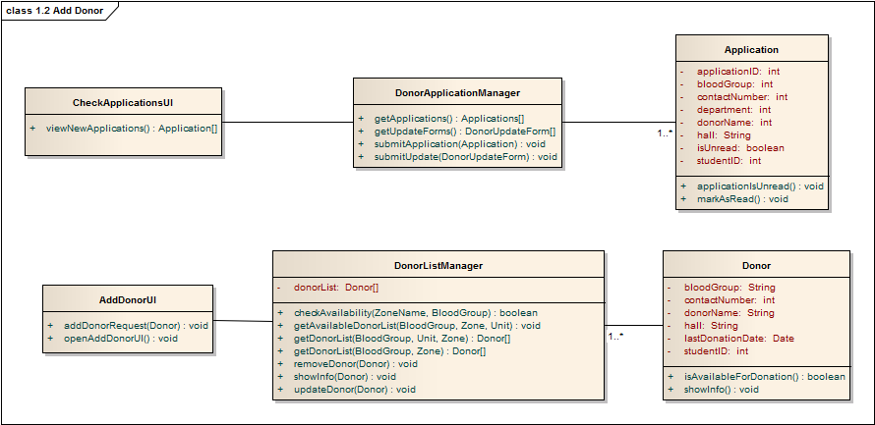

Fig 1.2.2: Class Diagram

* 1. **Remove Donor:**

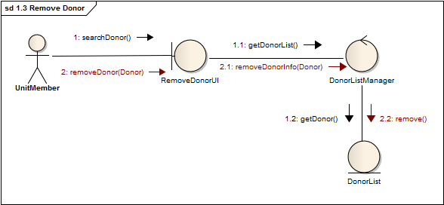

Fig 1.3.1: Collaboration Diagram

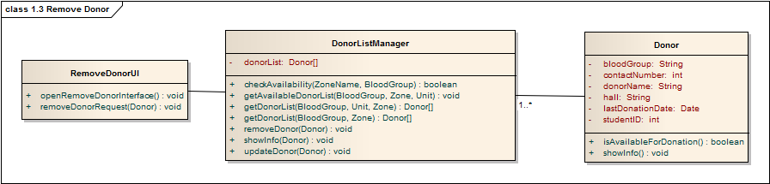

Fig 1.3.2: Class Diagram

* 1. **Donor Updates Regarding Donation:**

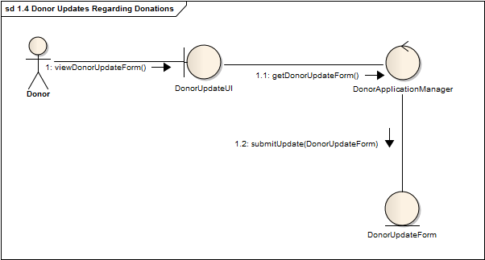

Fig 1.4.1: Collaboration Diagram

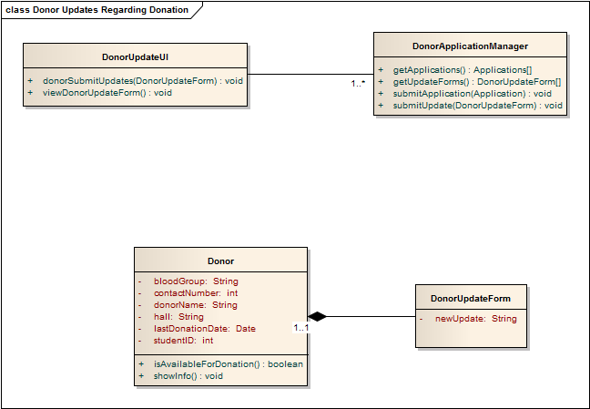

Fig 1.4.2: Class Diagram

* 1. **Donor Database Update:**

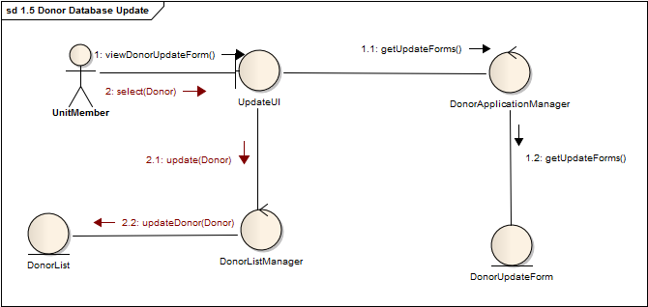

Fig 1.5.1: Collaboration Diagram

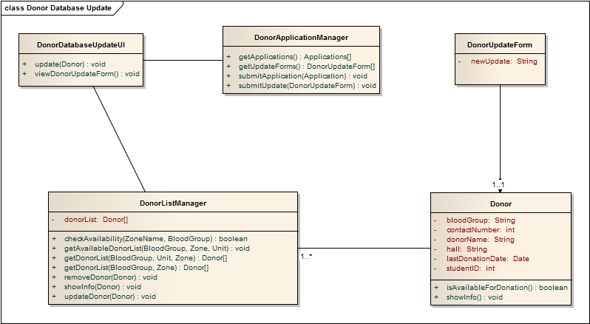

Fig 1.5.2: Class Diagram

* 1. **User Record:**

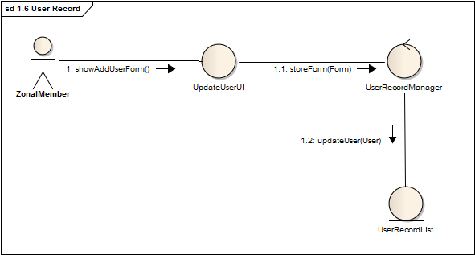

Fig 1.6.1: Collaboration Diagram

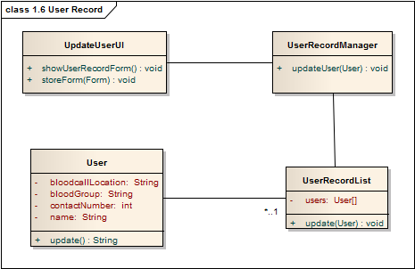

Fig 1.6.2: Class Diagram

* 1. **Member Record :**

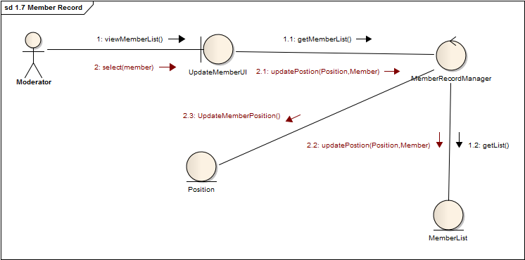

Fig 1.7.1: Collaboration Diagram

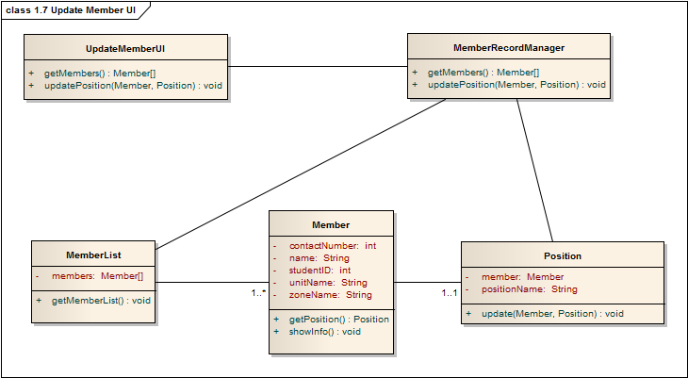

Fig 1.7.2: Class Diagram

**2. Search Management:**

2.1 **Donor Availability Search:**

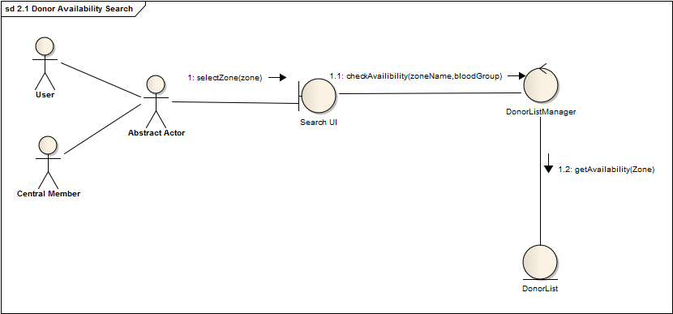

Fig 2.1.1: Collaboration Diagram

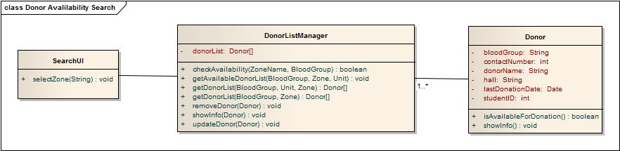

Fig 2.1.2: Class Diagram

**2.2** **Unit Donor Availability List:**

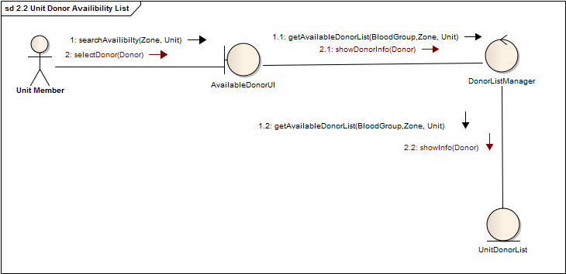

Fig 2.2.1: Collaboration Diagram

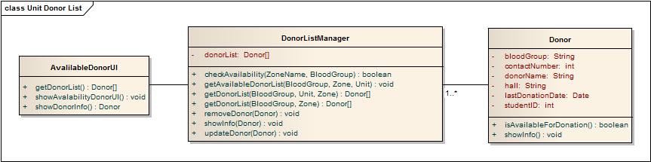

Fig 2.2.2: Class Diagram

**2.3 Member Search:**

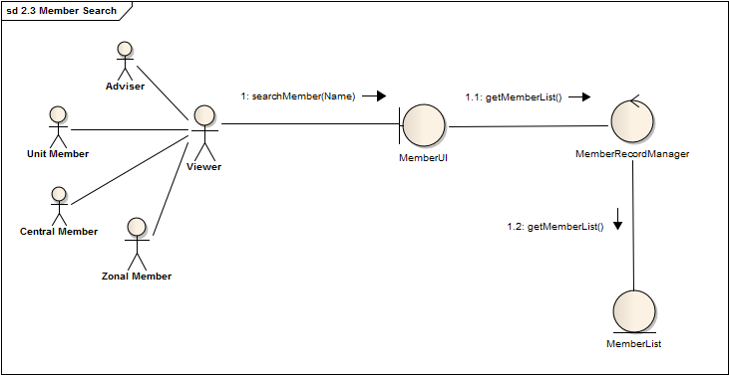

Fig 2.3.1: Collaboration Diagram

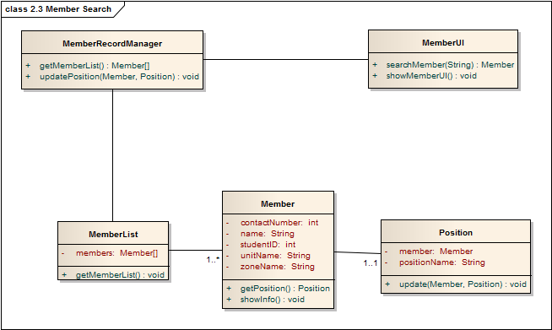

Fig 2.3.2: Class Diagram

**2.4 Zonal Donor Availability List:**

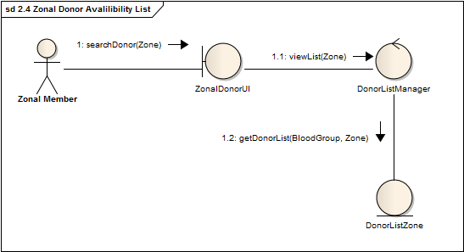

Fig 2.4.1: Collaboration Diagram

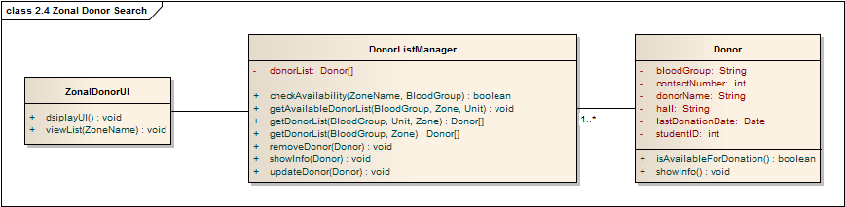

Fig 2.4.2: Class Diagram

3. Meeting Management:

**3.1 Zonal Event Creation:**

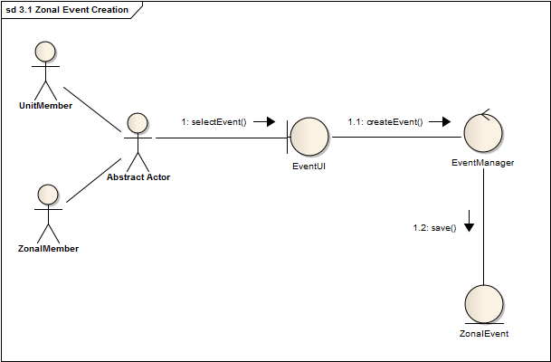

Fig 3.1.1: Collaboration Diagram

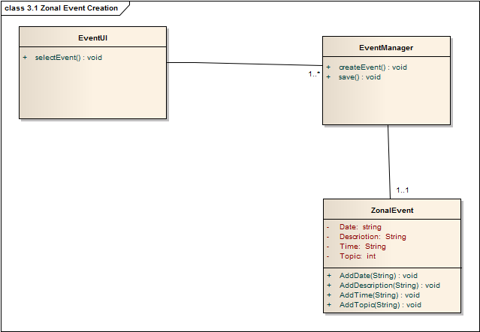

Fig 3.1.2: Class Diagram

**3.2 Zonal New Post:**

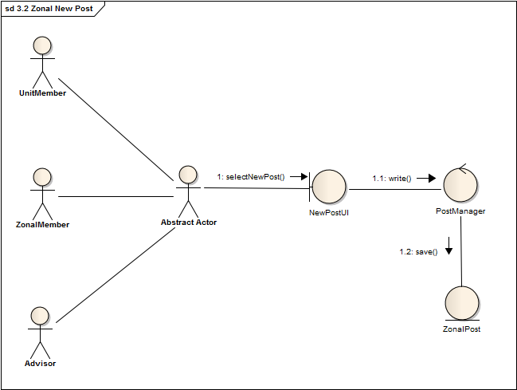

Fig 3.2.1: Collaboration Diagram

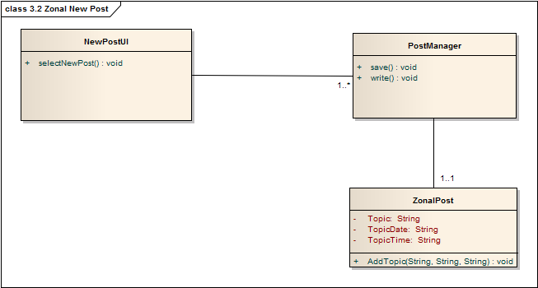

Fig 3.2.2: Class Diagram

**3.3 Zonal New Post Modification:**

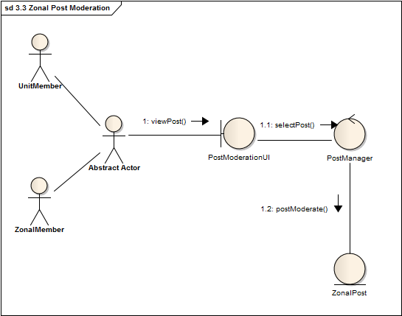

Fig 3.3.1: Collaboration Diagram

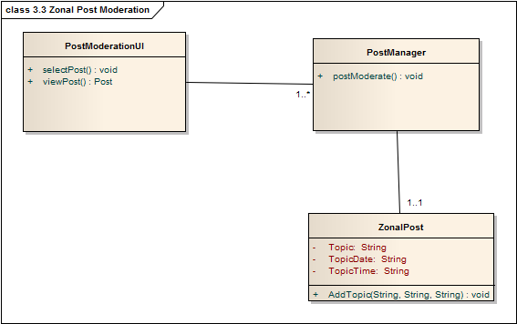

Fig 3.3.3: Class Diagram

**3.4 Zonal Post Remove:**

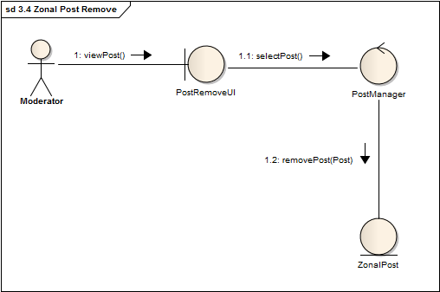

Fig 3.4.1: Collaboration Diagram

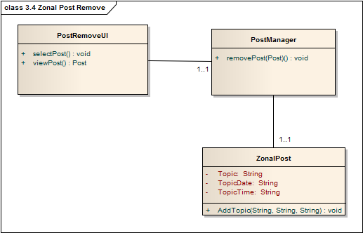

Fig 3.4.2: Class Diagram

**3.5 Central Event Creation:**

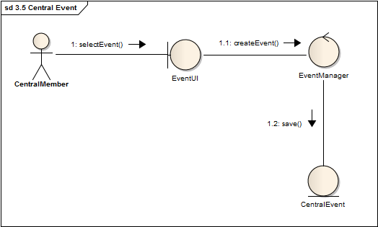

Fig 3.5.1: Collaboration Diagram

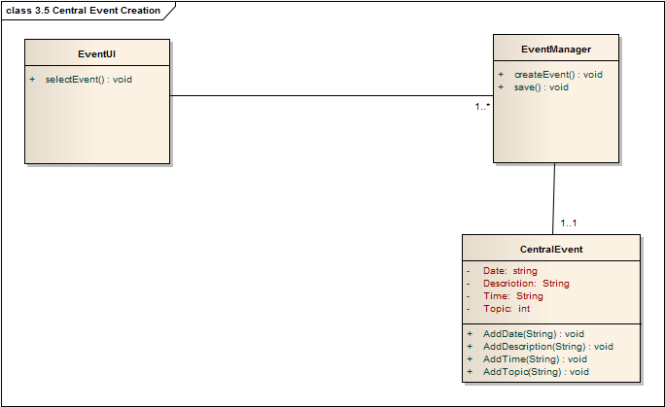

Fig 3.5.2: Class Diagram

**3.6 Central New Post:**

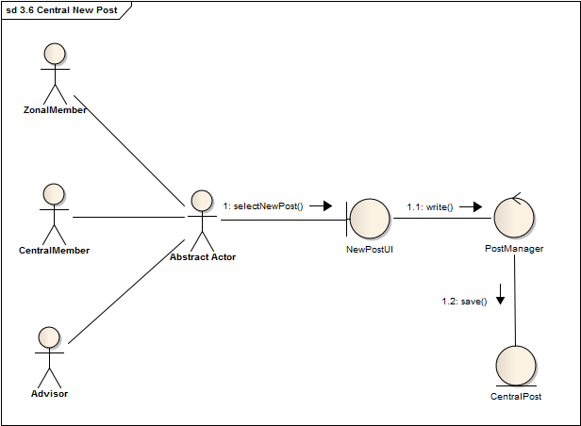

Fig 3.6.1: Collaboration Diagram

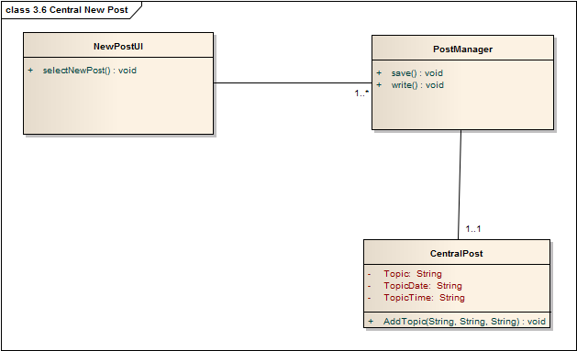

Fig 3.6.2: Class Diagram

**3.7 Central Post Moderation**

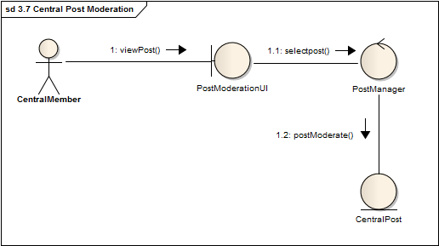

Fig 3.7.1: Collaboration Diagram

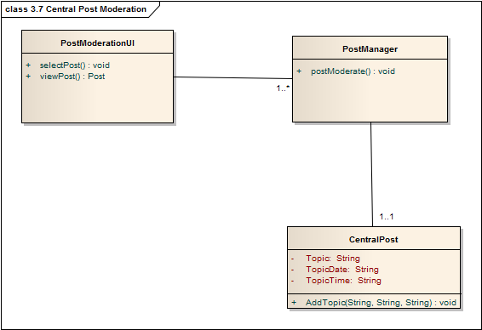

Fig 3.7.2: Class Diagram

**3.8 Central Post Remove:**

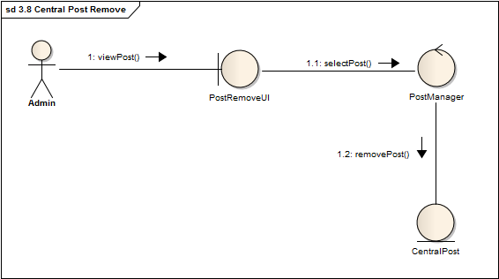

Fig 3.8.1: Collaboration Diagram

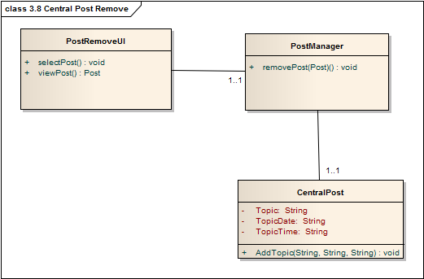

Fig 3.8.2: Class Diagram

**4. NOTIFICATION MANAGEMENT:**

**4.1 Donor Notification:**

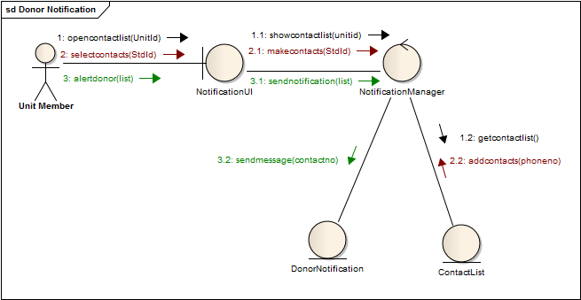

Fig 4.1.1: Collaboration Diagram

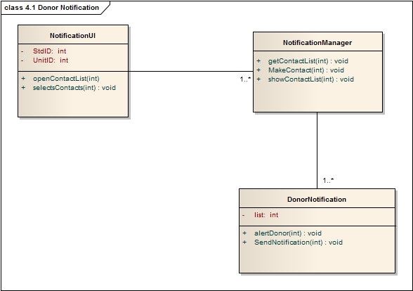

Fig 4.1.2: Class Diagram

**4.2 Zonal Meeting Notification:**

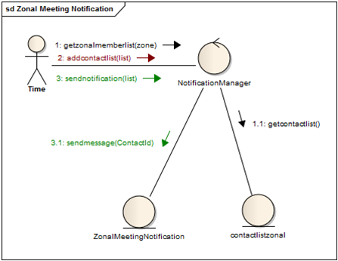

Fig 4.2.1: Collaboration Diagram

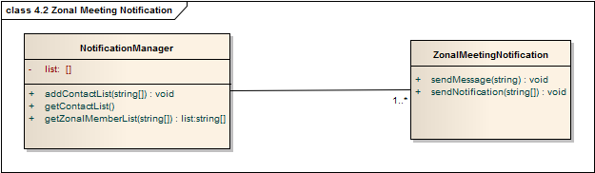

Fig 4.2.2: Class Diagram

**4.3 Central Meeting Notification:**

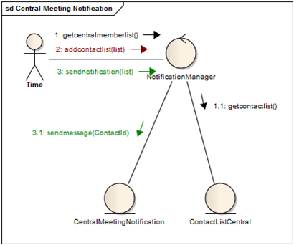

Fig 4.3.1: Collaboration Diagram

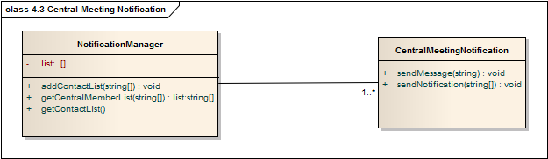

Fig 4.3.2: Class Diagram

1. **Automated Requisition Form Verification**

**5.1 Upload Requisition Form:**

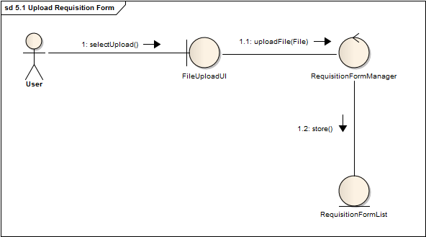

Fig 5.1.1: Collaboration Diagram

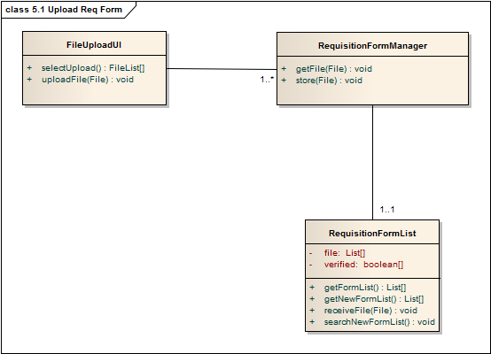

Fig 5.1.2: Class Diagram

**5.2(A) Verification of Requisition Form:**

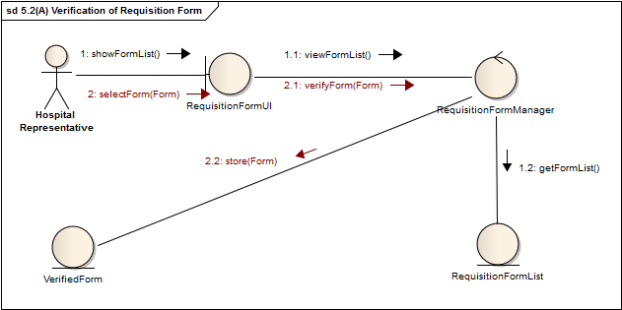

Fig 5.2.1(A): Collaboration Diagram

**5.2(B) Verification of Requisition Form:**

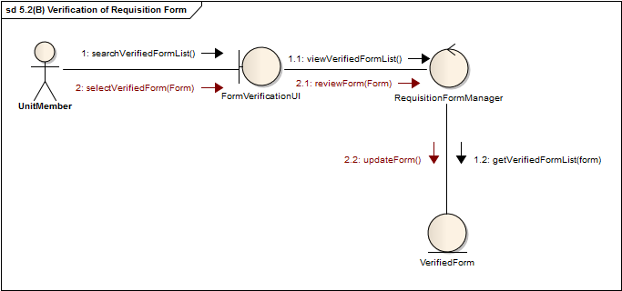

Fig 5.2.1(B): Collaboration Diagram

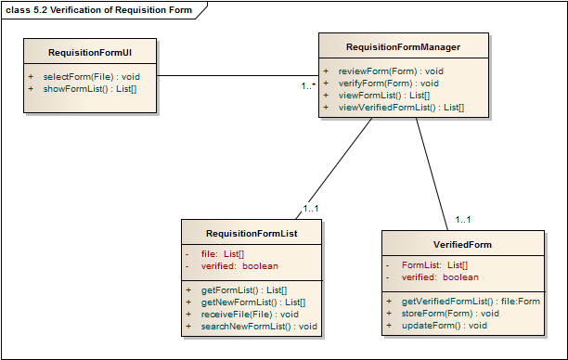

Fig 5.2.2: Class diagram